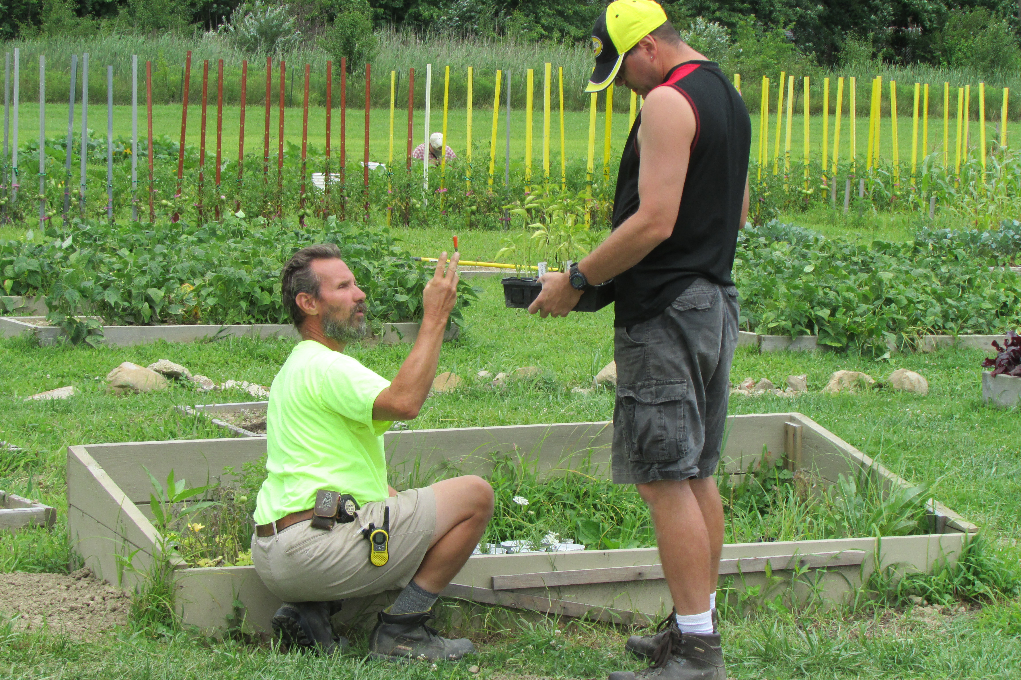
Joe says, "Everyday I look forward to what we are going to do that day - woodworking, farm work, planting vegetables and fetching water. I advertise our craft projects that I and others make at the farm when I go to church on Sunday. I have a lot of fun working there - even in rotten weather. Everybody is really friendly to me - both staff and clients."
Joe's parents, Bill and Claudia, say ~ "Joe was in a vocational horticulture program in high school and loves to be active and work outdoors. He enjoys working in the garden, mowing the lawn and building furniture in the woodworking shop. One of his favorite activities is helping to care for the animals. He loves the variety that the farm offers him."
"It is wonderful that Joe is playing an active part in a new, upcoming and growing community experience. Joe makes daily phone calls home full of excitement about what he has done on the farm that day. We are thrilled that Joe's needs are being met as he continues to show growth in his independence."

