Agricultural Innovation on the Farm
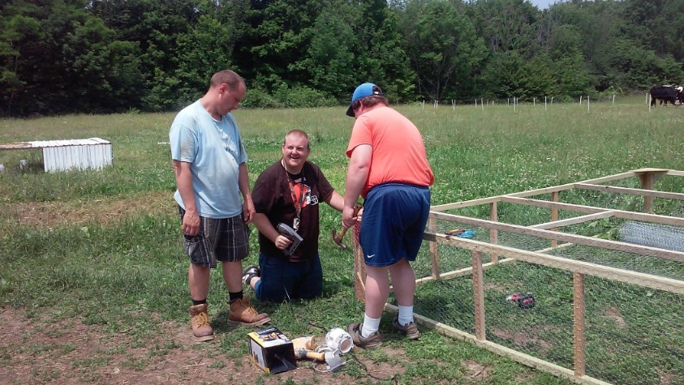Over the last few weeks at Hiram Farm, our farmers have been hard at work building new tractors. These aren’t the sort of tractors you normally see on a farm, though. No tires or engines here—these are “chicken tractors,” or portable chicken coops.
Moveable chicken coops were made famous by “alternative farmer” Joel Salatin, whose family runs the organic and non-industrial Polyface Farm in Virginia. Our new Farm Manager, Jason Bricker-Thompson and a few of Hiram Farm board members heard Salatin speak at Hiram College’s campus in March 2013. Implementing some of Salatin’s techniques will be an exciting goal for the farm this year.
Like all of Salatin’s innovations, portable chicken coops are designed to allow every component of the farm to work together as they would in nature, which makes for agriculture that is surprisingly productive and self-sufficient. Simple wooden frames covered with chicken wire and re-purposed sheet metal, are much more impressive than they seem at first glance. The tractors are moved across our pastures, a few feet each day by our farmers, preventing disease by allowing access to nutritious grass and insects, unlike the chickens confined in factory farms. The movement also allows for a strategic and natural fertilization of our pasture. The tractors provide protection from sun, rain, and predators, missing from the lives of free-range chickens.
This innovative project is a great experience for our farmers. They are able to show off their carpentry skills in the building process, while being flexible as we adapted the plans for each tractor to make the best use of reclaimed materials. During the building process, we were excited to watch the 100 new chicks grow stronger in the barn, and then move them outside to their new homes. Our customers will be happy to learn that the chicken tractors will provide shelter for three dozen new layer hens, and we will be producing many more eggs, as well as meat chickens in the early fall.
Many of customers express sheer delight at having locally grown food. There is a growing movement toward smaller farms because of the impact industrial farming has on the environment and the deplorable treatment of animals. These five new “tractors” are just one of the many examples of how creativity, hard work, and a strong sense of community come together at Hiram Farm to create wonderful opportunities for learning, environmental responsibility, and good food.
The above information is from PolyfaceFarms.com and Dr. Mercola Discusses Chickens with Joel Salatin at Polyface Farm.

